**REAL-TIME RESEARCH PROJECT REPORT**

**on**

**SHOPPING CART APPLICATION**

***Submitted in Partial fulfilment of the requirements for the award of the degree of***

**BACHELOR OF TECHNOLOGY**

**IN**

**COMPUTER SCIENCE AND ENGINEERING**

**SUBMITTED BY**

|  |  |
| --- | --- |
| **Asha kunnel** | **22D21A05C5** |
| **B. Jyothika** | **22D21A05C6** |
|  |  |



**ESTD: 2001**

***Department Of Computer Science and Engineering***

**SRIDEVI WOMEN’S ENGINEERING COLLEGE**

**(Approved by AICTE and Affiliated to JNTUH, Hyderabad and Accredited by NBA and NAAC An ISO 9001:2015 Certified Institution)**

**V.N.PALLY, Gandipet, Hyderabad-107**

**2023-2024**

|  |  |  |
| --- | --- | --- |
|  | ***Department Of Computer Science and Engineering***  **SRIDEVI WOMEN’S ENGINEERING COLLEGE**  **(Approved by AICTE and Affiliated to JNTUH, Hyderabad and Accredited by NBA and NAAC**  **An ISO 9001:2015 Certified Institution)**  **V.N.PALLY, Gandipet, Hyderabad-107**  **2023-2024** |  |



**CERTIFICATE**

This is to certify that the Real-time research project report entitled **“SHOPPING CART APPLICATION”** is being submitted by **Ms ASHA KUNNEL (22D21A05C5)** and **Ms. B.JYOTHIKA (22D21A05C6)** in partial fulfilment for the award of the degree **Engineering** of **Bachelor of Technology** in **Computer Science and** is a record of bonafide work carried out by them.

|  |  |  |
| --- | --- | --- |
| **Coordinator** |  | **Head of the Department** |
|  |  |  |
|  |  |

**INDEX**

|  |  |  |
| --- | --- | --- |
| **S.NO** | **Title** | **PAGE NO.** |
| 1 | Introduction | 1 |
| 2 | Hardware and Software Requirements | 2 |
| 3 | Functionally of The Application | 3– 4 |
| 4 | Sample Code | 5 – 12 |
| 5 | Sample Output | 13- 16 |
| 6 | Conclusion | 17 |

**1. INTRODUCTION**

The Project entitled "ONLINE SHOPPING CART" is a web-based application. Software developed in Windows operating system using HTML, CSS, and JAVASCRIPT As frontend. The main aim of the project is to improve the services of Customers and vendors. It maintains the details of customer payments, product receipts, the addition of new customers, and products and also updates, and deletions for the same. It also mails the details of users who have logged in to the shopping portal to the email ID that they have given during the signup process. The primary features of the project entitled are high accuracy, design flexibility, and easy availability. Also, it uses database tables representing entities and relationships between entities.

Online shopping is the process of buying goods and services from merchants who sell on the Internet. Since the emergence of the World Wide Web, merchants have sought to sell their products to people who surf the Internet. Shoppers can visit web stores from the comfort of their homes and shop as they sit in front of the computer.

Consumers buy a variety of items from online stores. People can purchase just about anything from companies that provide their products online. Books, clothing, household appliances, toys, hardware, software, and health insurance are just some of the hundreds of products consumers can buy from an online store. Many people choose to conduct shopping online because of the convenience.

Key Features:

1. Login

2. Ordering

1. Ordering History

**1**

**2. HARDWARE AND SOFTWARE REQUIREMENTS**

To ensure the smooth operation of a shopping cart application, specific hardware and software requirements must be met.

**i)Hardware Requirement**

**Processor:** Intel i5 or Higher

**RAM:** 8GB or more

**Hard disk:** 500 GB SSD

**ii) Software Requirements**

**Front-end Languages:** HTML, CSS, JavaScript

**Back-end Languages:** Python 3.7 Version

**Frameworks:** Flask/Django(for Python)

**IDE:** Anaconda 3.7/Text editor(for Python development)

**Libraries:** Bootstrap, JQuery

**Version Control:** Git

**Database:** SQLite/MySQL

**2**

**3.FUNCTIONALITY OF THE APPLICATION**

**1. User Account Management:**

* **Registration and Login:** Allow users to create accounts, log in securely, and manage their profiles.
* An shopping cart application must provide a wide range of functionalities to ensure a smooth, user-friendly, and efficient experience for travellers. Here are the core functionalities such an application should offer:
* **Password Recovery:** Provide options for users to reset forgotten passwords.

**2. Items Search and Booking:**

* **Product Search:** Enable users to search for products based on criteria like electronics, toys, home & kitchen, jewerelly.
* **Filters and Sorting:** Allow users to filter and sort search results by price, duration other preferences.
* **Product Details:** Provide detailed information about each product option, including their price, rating, description.

**3. Booking Management:**

* **Booking Confirmation:** Send booking confirmation via email and SMS with all necessary details.
* **View Bookings:** Allow users to view and manage their current and past bookings.
* **Modify or Cancel Booking:** Provide options to modify or cancel order based on the shopping policies.

**3**

**4. Payment Processing:**

* **Multiple Payment Methods:** Support various payment options, including credit/debit cards, digital wallets, and bank transfers.
* **Secure Payment Gateway:** Ensure secure payment processing through trusted gateways.
* **Payment Confirmation:** Provide immediate payment confirmation and transaction receipts.

**5. Notifications and Alerts:**

* **Product Status Updates:** Provide real-time notifications on product status, delays, gate changes, and cancellations.
* **Promotional Offers:** Notify users of special offers, discounts, and loyalty program updates.

**6. Customer Support:**

* **Live Chat and Support:** Offer live chat support, email support, and phone support for customer inquiries and issues.
* **FAQ and Help Centre:** Provide a comprehensive FAQ section and help centre for common queries and self-service.

**7. User Experience Enhancements:**

* **Personalization:** Provide personalized recommendations based on user preferences and past booking history.
* **User Reviews and Ratings:** Allow users to read and leave reviews and ratings for products and services.

**8. Security and Privacy:**

* **Data Encryption:** Ensure all user data is encrypted in transit and at rest.
* **Privacy Policies:** Communicate privacy policies and obtain user consent for data

**4**

**4. SAMPLE CODE**

<! DOCTYPE html>

<html lang="en">

<head>

<meta charset="UTF-8">

<meta name="viewport" content="width=device-width, initial-scale=1.0">

<title>Simple Shopping Website</title>

<style>

body {

font-family: Arial, sans-serif;

margin: 0;

padding: 0;

}

header {

background-color: #333;

color: #fff;

padding: 1em 0;

text-align: center;

}

nav ul {

list-style-type: none;

padding: 0;

}

nav ul li {

display: inline;

margin: 0 10px;

}

nav ul li a {

color: #fff;

**5**

text-decoration: none;

}

main {

padding: 40px;

}

.product-grid {

display: flex;

gap: 20px;

flex-wrap: wrap;

}

.product {

border: 1px solid #ccc;

padding: 10px;

width: 200px;

text-align: center;

}

.product img {

max-width: 100%;

}

.category {

border: 1px solid #ccc;

padding: 20px;

margin: 20px auto;

width: 200px;

height: 200px;

border-radius: 50%;

text-align: center;

display: flex;

flex-direction: column;

justify-content: center;

**6**

align-items: center;

}

.category h3 {

margin: 0;

}

footer {

background-color: #333;

color: #fff;

text-align: center;

padding: 1em 0;

position: fixed;

width: 100%;

bottom: 0;

}

.hidden {

display: none;

}

.login-form {

**max-width: 300px;**

margin: 50px auto;

padding: 20px;

border: 1px solid #ccc;

text-align: center;

}

.login-form input {

display: block;

width: calc(100% - 20px);

margin: 10px auto;

padding: 10px;

}

.login-form button {

**7**

padding: 10px 20px;

}

</style>

</head>

<body>

<header class="hidden" id="main-header">

<img src="aj.jpg" alt="Shop Logo" style="max-width: 150px;">

<h1>Welcome to Our Shop</h1>

<nav>

<ul>

<li><a href="#" onclick="showSection('home')">Home</a></li>

<li><a href="#" onclick="showSection('products')">Products</a></li>

<li><a href="#" onclick="showSection('cart')">Cart</a></li>

</ul>

</nav>

</header>

<main id="login">

<div class="login-form">

<h2>Login</h2>

<input type="text" id="username" placeholder="Username">

<input type="password" id="password" placeholder="Password">

<button onclick="login()">Login</button>

</div>

</main>

<main id="home" class="hidden">

<section>

<h2>Product Categories</h2>

<div class="category">

<h3>Category 1</h3>

<p>Explore a variety of products in Category 1</p>

**8**

<button onclick="showSection('products')">View Products</button>

</div>

<div class="category">

<h3>Category 2</h3>

<p>Discover amazing deals in Category 2</p>

<button onclick="showSection('products')">View Products</button>

</div>

<!-- Add more categories as needed -->

</section>

</main>

<main id="products" class="hidden">

<section>

<h2>Our Products</h2>

<div class="product-grid">

<div class="product">

<img src="product1.jpg" alt="Product 1">

<h3>Product 1</h3>

<p>$10.00</p>

<button onclick="showSection('product1')">View Details</button>

</div>

<div class="product">

<img src="product2.jpg" alt="Product 2">

<h3>Product 2</h3>

<p>$20.00</p>

<button onclick="showSection('product2')">View Details</button>

</div>

<!-- More products -->

</div>

</section>

**9**

</main>

<main id="product1" class="hidden">

<section>

<img src="product1.jpg" alt="Product 1">

<h2>Product 1</h2>

<p>$10.00</p>

<button onclick="showSection('cart')">Add to Cart</button>

</section>

</main>

<main id="product2" class="hidden">

<section>

<img src="product2.jpg" alt="Product 2">

<h2>Product 2</h2>

<p>$20.00</p>

<button onclick="showSection ('cart')">Add to Cart</button>

</section>

</main>

<main id="cart" class="hidden">

<section>

<h2>Items in your cart</h2>

<ul>

<li>

<img src="product1.jpg" alt="Product 1">

<h3>Product 1</h3>

<p>$10.00</p>

<button>Remove</button>

**10**

</li>

<!-- More items -->

</ul>

<h3>Total: $10.00</h3>

<button>Checkout</button>

</section>

</main>

<footer class="hidden" id="main-footer">

<p>&copy; 2024 Shopping Website</p>

</footer>

<script>

function showSection(sectionId) {

const sections = document.querySelectorAll('main');

sections.forEach(section => {

section.classList.add('hidden');

});

document.getElementById(sectionId).classList.remove('hidden');

}

function login() {

const username = document.getElementById('username').value;

const password = document.getElementById('password').value;

if (username === 'user' && password === 'password') {

document.getElementById('main-header').classList.remove('hidden');

document.getElementById('main-footer').classList.remove('hidden');

showSection('home');

} else {

**11**

alert('Invalid login credentials');

}

}

</script>

</body>

</html>

**12**

**6 .SAMPLE OUTPUT**

**FIGURE 1:** Login Application for online shopping

Here we can see a login page of online shopping enter the username, password to access to your account

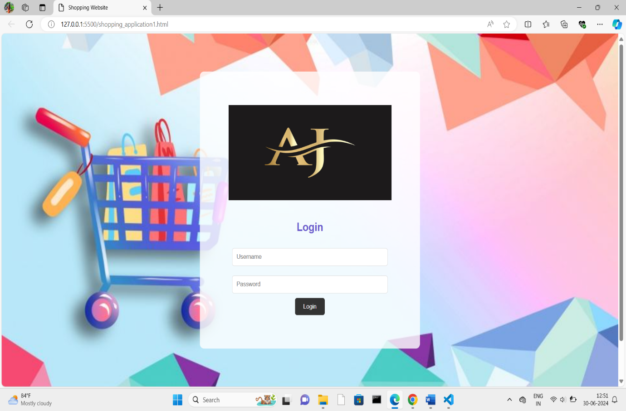

**13**

**FIGURE 1:** Login Application for online shopping

This page will redirect to main application

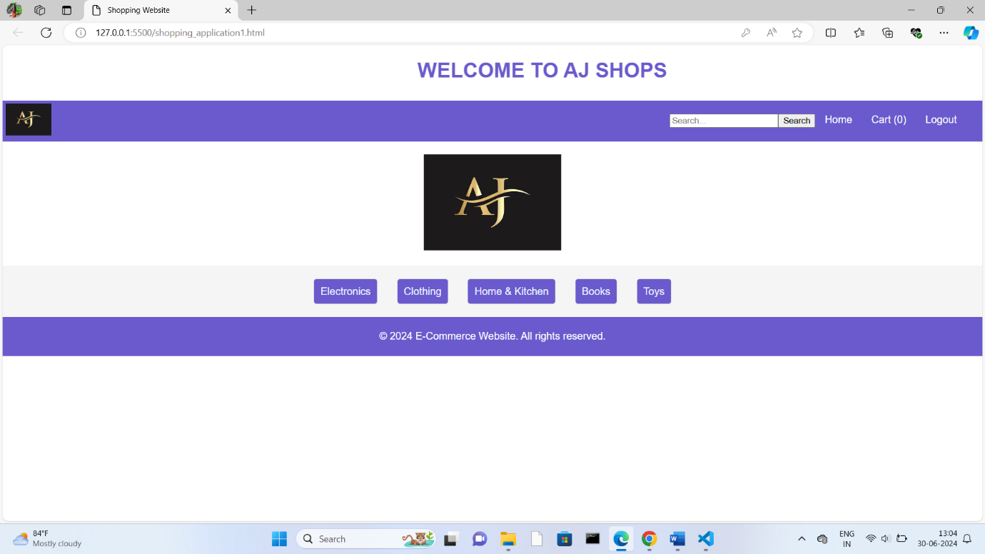**Figure 2** : Main Application of Online shopping Application

Here we can see the main page of the application that welcomes the user.

Here we see the options like home, cart, and logout.

**14**

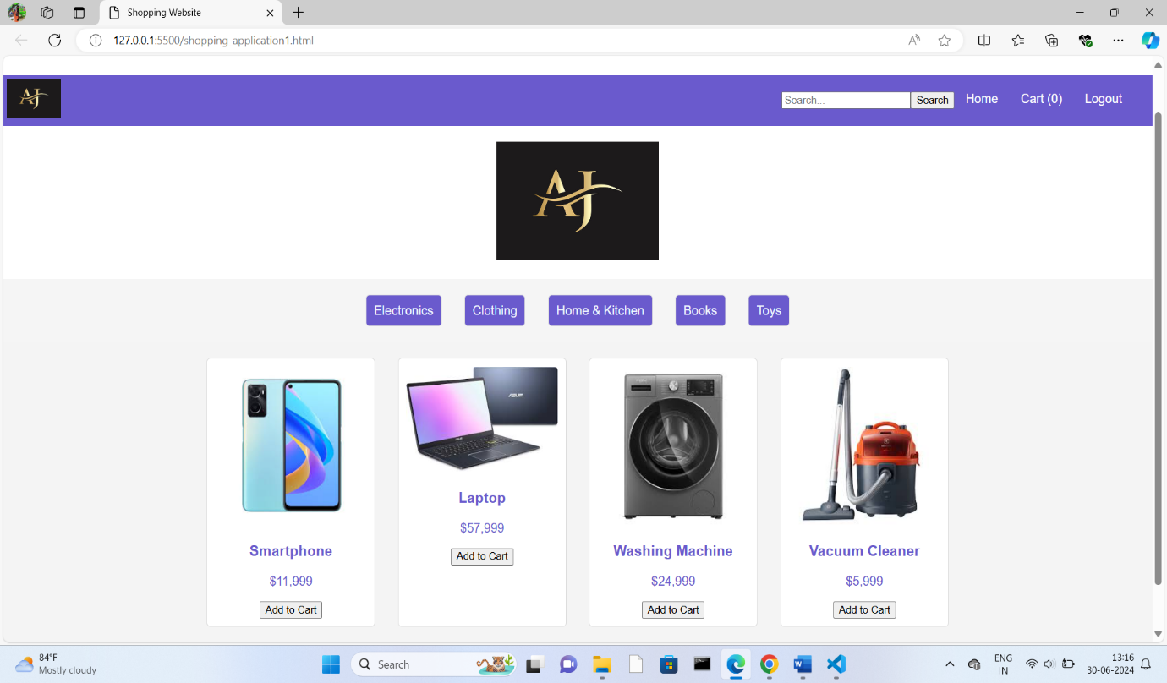 **Figure 3**: products can be seen here

Here we can the products of the categories and user can place the products into there carts.

**15**

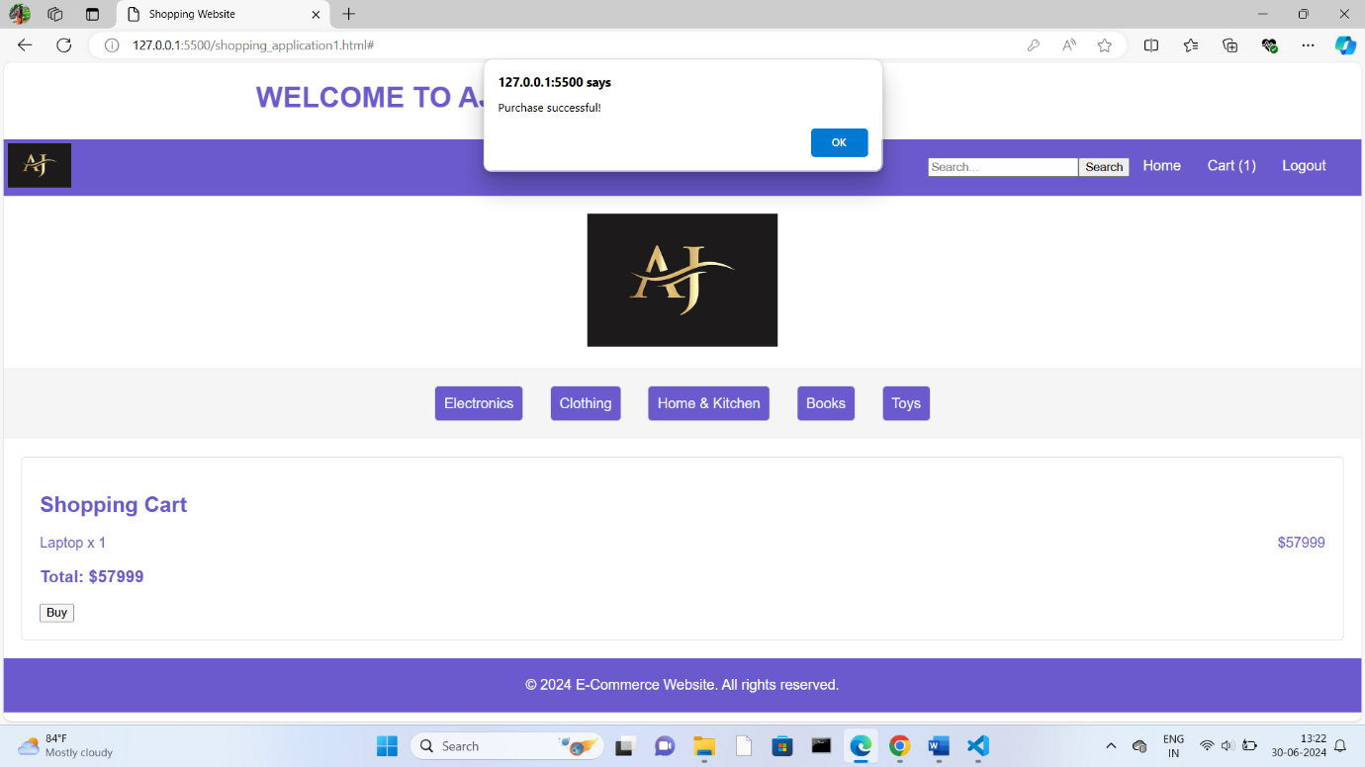

**Figure 4:** The products can purchased here

Here user can see their products which they added to cart and can by the products.

**16**

**7. CONCLUSION**

The central concept of the application is to allow the customer to shop virtually using the Internet and allow customers to buy the items and articles of their desire from the store. The information pertaining to the products are stores on an RDBMS at the server side (store). The Server process the customers and the items are shipped to the address submitted by them.The application was designed into two modules first is for the customers who wish to buy the articles. Second is for the storekeepers who maintains and update the information. The end user of this product is a departmental store where the application is hosted on the web and the administrator maintains the database.

**17**